BOARD MEMBERS

WILLIAM H. KUYKENDALL, J.D. CHAIRMAN
AUSTIN

RONALD L. BROWN
DRIPPING SPRINGS

MARY LOU DAUGHTREY
TYLER

JAMES H. DICKERSON, J.D.
LAKE JACKSON

SAN JUANA C. GARZA
WESLACO

TERISSA JOHNSON
SANGER

JANIS E. WIGGINS
KINGSLAND
GLENN D. PARKER
EXECUTIVE DIRECTOR
glenn.parker@tsbbe.state.tx.us

STATE BOARD OF BARBER EXAMINERS
http://www.tsbbe.state.tx.us
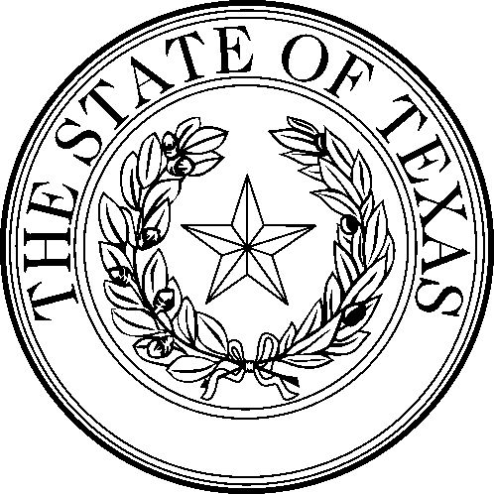

STATE BOARD OF BARBER EXAMINERS
5717 Balcones Dr., Ste 217
Austin, Texas 78731
(512) 936-6333 (888) 870-8755 FAX (512) 458-4901

Summary of Minutes for TSBBE Board Meeting

Held:

Monday, June 6, 2005

Meeting Location: 5717 Balcones Drive, Austin, Texas 78731

1. Pursuant to Chapter 551 of the Texas Government Code (Open Meetings), meeting was called to order at 2:50 pm and roll called by Ron Brown, Vice Chairman. Board members in attendance were Mr. Ron Brown, Mr. James Dickerson, Ms. Mary Lou Daughtrey, Ms. Terissa Johnson, and Ms. Janie Garza. Mr. William Kuykendall was not present at the beginning of the meeting but joined the meeting at approximately 3:00 pm. Board Member Ms. Janis Wiggins were not present. Mr. Jeb Boyt, J.D., from the Office of the Attorney General was also present. Staff members present were Mr. Glenn Parker, Mr. Jerry Daniels, and Ms. Gloria Torres.

2. The board approved the Certificates of Appreciation for certain individuals in recognition of their 50 or more years of service as licensed barbers. All board members present signed the certificates.

3. Motion made by Mr. Dickerson to accept minutes of April 4, 2005. The motion was seconded by Ms. Daughtrey and passed unanimously.

4. Public Comments – Ms. Jane Owens, a barber from Austin, expressed her interest in being informed of any new laws or rules that will be effective with the new fiscal year on September 1, 2005.

5. Executives of the Texas Department of Licensing and Regulation made a presentation to the Board and answered questions concerning the transfer of the Barber Board responsibilities to TDLR on September 1, 2005. Mr. William (Bill) Kuntz, Executive Director, and Mr. Brian Francis, Deputy Executive Director, made the presentation for TDLR.

6. Motion made by Mr. Brown to approve Proposals for Decisions (PFDs) from State Office of Administrative Hearings for SOAH hearings held on January 20, 2005 for the individuals listed below, and was seconded by Mrs. Johnson. Motion passed unanimously.

January 20, 2005 SOAH Hearings

PFDs With Recommendations to Uphold:
1. Stalin Henderson, File #238317, SOAH Docket #502-05-2852.W
2. Rhonda M. Caleb, File #224698, SOAH Docket #502-05-2854.W
3. Artie M. Niver, File #59048, SOAH Docket #502-05-2857.W
4. Patrick K. Rhodes, File #220655, SOAH Docket #502-05-2872.W
5. John De La Paz, File #45747, SOAH Docket #502-05-2853.W
6. Kandy L. Pramuk, File #61407, SOAH Docket #502-05-2856.W
7. Daniel Waldrup, File #221828, SOAH Docket #502-05-2858.W
8. Jeremiah Perez, File #235633, SOAH Docket #502-05-2859.W
9. Jozetta Marie Griffin, File #233123, SOAH Docket #502-05-2864.W
10. Mark Anthony Jone, File #229964, SOAH Docket #502-05-2865.W
11. Michael Benjamin, File #237641, SOAH Docket #502-05-2867.W
12. Bobby L. Crump, File #226098, SOAH Docket #502-05-2870.W
13. Calvin J. Green, File #238601, SOAH Docket #502-05-2869.W
14. Christopher Henderson, File #235720, SOAH Docket #502-05-2861.W
15. Jarvis Oaks, File #230456, SOAH Docket #502-05-2862.W
16. Ron Christopher Artmore, File #229056, SOAH Docket #502-05-2863.W
17. Jesus Ortuno, File #220889, SOAH Docket #502-05-2868.W
18. Rhonda Jackson, File # None, SOAH Docket #502-05-2871.W
19. Elouise West, File #51219, SOAH Docket #502-05-2874.W

PFDs With Recommendations to Dismiss:

None

7. Glenn Parker reported on Informal Hearings and reason for any reductions on fines. Motion to accept made by Mrs. Daughtrey and seconded by Mr. Brown. Mr. Dickerson voted no. Motion passed 5-1.

- Ramiro Morales, File #45103
- Ezequiel Ortuno, File #60162
- Beatrice Ufom , No File #

8. Mr. Dickerson made motion for final adoption of the proposed revisions to the fines schedule in Rule 51.3 (Administrative Fines) to change the penalty for the first offense for not having a booth rental permit or for working with an expired booth rental permit from a “Warning” to a fine of $100. Motion was seconded by Ms. Johnson and passed 6-0.

9. Mr. Dickerson made a motion to repeal Rule 51.51 concerning the method of payment of fees. The motion was seconded by Ms. Daughtrey and passed 6-0.

10. Ms. Daughtrey made a motion to repeal Rule 51.55 concerning the required number of questions that shall be on examinations administered by the Board. The motion was seconded by Mr. Dickerson. Mr. Brown expressed concern that too many questions might be detrimental to certain students who have learning disabilities or who cannot operate a computer easily. The Board voted 6-0 to repeal Rule 51.55 and to ask the Texas Department of Licensing and Regulation to be aware of the need to accommodate the testing needs of certain students.

11. Ms. Daughtrey made a motion to repeal Rule 51.77 concerning the requirements for obtaining a barber shop permit. The motion was seconded by Mr. Brown and passed 6-0.

12. Ms. Daughtrey made a motion to amend Rules 51.12, 51.13, 51.20, 51.21, 51.25, 51.27, 51.60, 51.80, and 51.85 as recommended in documents presented by staff in preparation for the transfer of functions to the Texas Department of Licensing and Regulation. The motion was seconded by Mr. Dickerson and passed 6-0. The Board also expressed its concern that TDLR continue to have barber schools inspected by barber inspectors and to provide education to barbers concerning sterilization and sanitation issues.

13. Executive Director Glenn Parker gave the Board updates on agency activities and operations including, but not limited to, the agency’s intention to publish a newsletter in late July or early August. He asked Mr. Kuykendall to contribute an article on any subject of his choosing. Mr. Kuykendall asked that TDLR give consideration to ensuring that the number of FTEs working on the regulation of barbering relatively near the current number.

14. Jerry Daniels presented the financial and operations reports, including year-to-date revenue and expenditure reports, student enrollment reports, and examination results report.

15. Ms. Daughtrey made a motion to the approve the agency’s request to be exempted from participation in the Texas Online Licensing Project, pending the outcome of HB 2593 which would prohibit the Authority from charging fees to barbers for their participation.

16. The Board decided to have its final board meeting on August 1, 2005 and adjourned at 5:27 pm.

