BOARD MEMBERS

CHARLES WILLIAMS, CHAIRMAN
SAN ANTONIO

ERNEST PACK
WACO

VICTORIA A. BUCHANAN
HOUSTON

WILLIAM “KIRK” KUYKENDALL
AUSTIN

WAYNE MOORE
GARLAND

JANIS E. WIGGINS
KINGSLAND
WILL K. BROWN
EXECUTIVE DIRECTOR
will.brown@tsbbe.state.tx.us

STATE BOARD OF BARBER EXAMINERS
http://www.tsbbe.state.tx.us
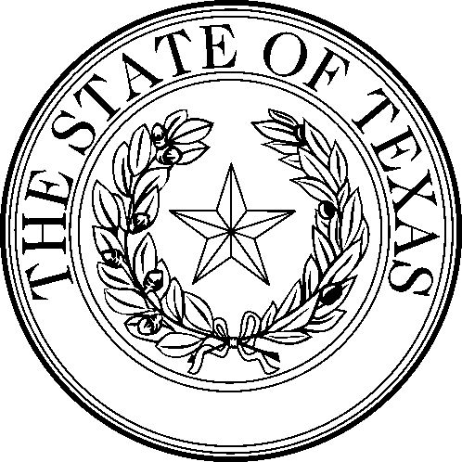

STATE BOARD OF BARBER EXAMINERS
333 Guadalupe, Suite 2-110
Austin, Texas 78701
(512) 305-8475 FAX 305-6800

MINUTES
Meeting of the State Board of Barber Examiners was held November 7, 2000, at the William P. Hobby State Office Building, Tower 2, Room 400-A, Austin, Texas. In attendance were Chairman Charles Williams, Board Members Wayne Moore, Ernest Pack, Janis Wiggins, William Kuykendall, Victoria Buchanan, Executive Director Will K. Brown, Attorney General Representative Joe Pitner, Chief Inspector Doug Lennox, Inspectors Louis Ponce and Jack Rogers, Accountant IV Debbie Almasov, Accountant II Yvonne Shaw and Administrative Technician III Kimberly M. Polanco.

OPEN SESSION

CALL TO ORDER: Chairman Williams called the meeting to order at 9:30 a.m.

READ AND APPROVE MINUTES OF BOARD MEETING AUGUST 8, 2000.

MOTION: A motion was made by Mr Pack and seconded by Mrs. Wiggins to approve the minutes of the August 8, 2000 meeting.
Motion unanimously carried.

OPEN FORUM:
Invited Guest: Judge Cecil Hanna, with Texas Department of Transportation.
Discussion of Do’s and Don’t of appearing before an Administrative Law Judge.

OPEN SESSION
Report on TSBBE Financial Budget for Fiscal Years 1998, 1999, 2000, 2001 presented by Debbie Almasov Accountant IV.

Discussion and review of TSBBE Administrative Fine Report, presented by Yvonne Shaw, Accountant III.

Report on TSBBE Financial Budget, presented by Yvonne Shaw, Accountant III.

November 7, 2000, Board Meeting, page 1
Report on TSBBE meeting with Senator Duncan, presented by Chairman Charles Williams.

Discussion and possible action regarding Senator Duncan’s Merger with Texas Cosmetology Commission Proposal.

MOTION: A motion was made by Mr. Kuykendall and seconded by Mr Moore to discuss in executive session.
Motion unanimously carried.

EXECUTIVE SESSION: 11:00 p.m.
OPEN SESSION: 12:05 p.m.

Discussion and possible action regarding Article 8405(a) –Cleanliness, concerning updating the cleaning methods used for Sanitation and Sterilization.

MOTION: A motion was made by Mr. Moore and seconded by Mrs. Wiggins draft proper language to 8405 Cleanliness to be included in the recommended changes.
Motion unanimously carried

MOTION: A motion was made by Mr. Kuykendall and seconded by Ms. Wiggins that the board respond in writing with the Chairman’s signature to decline Senator Duncan’s request to draft language regarding the merger with Texas Cosmetology Commission.
Motion unanimously carried.

Discussion and possible action regarding Rule Review Committee’s Recommendations on new rules for renewals, good standing and address changes required.

MOTION: A motion was made by Mr. Moore and seconded by Mr. Kuykendall to accept the new rules 51.4; 51.5; 51.6 with changes.
Motion unanimously carried.

MOTION: A motion was made by Ms. Wiggins and seconded by Mr. Moore to accept the new rule 51.141 with changes.
Motion unanimously carried.

Discussion and possible action regarding the time allowed to proceed with the finding a sponsor for the proposed Law Review Committee's Recommendations.

MOTION: A motion was made by Mr. Kuykendall and seconded by Ms. Wiggins to request Mr. Moore to seek a sponsor for the proposed Law changes.
Motion unanimously carried.

November 7, 2000, Board Meeting, page 2
Discussion and possible action regarding Tabled item from August 8, 2000 Board Meeting regarding directing agency staff to make rule changes to conform with statute changes.

MOTION: A motion was made by Ms. Moore and seconded by Ms. Wiggins to direct staff to make rule changes that correspond with the statute changes and present to the board.
Motion unanimously carried.

Discussion and possible action regarding 2001 Examination Schedule.

MOTION: A motion was made by Mr. Moore and seconded by Mr. Kuykendall to accept the Examination Schedule.
Motion unanimously carried.

Discussion and possible action regarding Administrative Fines referred to SOAH, Informal conferences and Dismissed Cases.

MOTION: A motion was made by Mr. Moore and seconded by Mr. Kuykendall to accept the Administrative Fines, Informal Conferences and Dismissed Cases and that the Board Members sign the approval.
Motion unanimously carried.

EXECUTIVE DIRECTORS REPORT

ADJOURN: Chairman Williams adjourned the meeting of November 7, 2000, at 1:19 p.m.

I certify that all statements made are to the best of my knowledge true and correct.

_______________________________________
Kimberly M Polanco, Administrative Technician

November 7, 2000, Board Meeting, page 3

