BOARD MEMBERS

CHARLES WILLIAMS, CHAIRMAN
SAN ANTONIO

ERNEST PACK
WACO

VICTORIA A. BUCHANAN
HOUSTON

WILLIAM “KIRK” KUYKENDALL
AUSTIN

WAYNE MOORE
GARLAND

JANIS E. WIGGINS
KINGSLAND
WILL K. BROWN
EXECUTIVE DIRECTOR
will.brown@tsbbe.state.tx.us

STATE BOARD OF BARBER EXAMINERS
http://www.tsbbe.state.tx.us
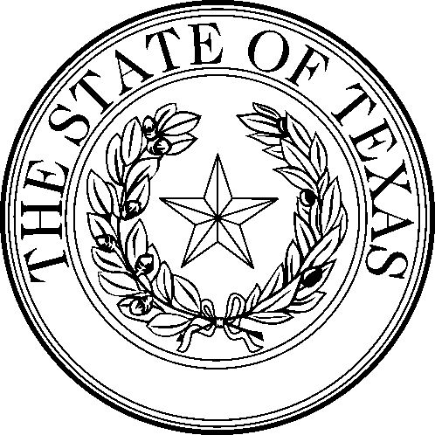

STATE BOARD OF BARBER EXAMINERS
333 Guadalupe, Suite 2-110
Austin, Texas 78701
(512) 305-8475 FAX 305-6800

MINUTES
Meeting of the State Board of Barber Examiners was held June 5, 2000, at the William P. Hobby State Office Building, Tower 2, Room 400-A, Austin, Texas. In attendance were Chairman Charles Williams, Board Members Wayne Moore, Ernest Pack, Janis Wiggins, William Kuykendall, Victoria A. Buchanan, Executive Director Will K. Brown, Attorney General Representative Joe Pitner, Chief Inspector Doug Lennox and Administrative Technician Kimberly M. Polanco.

OPEN SESSION

CALL TO ORDER: Chairman Williams called the meeting to order at 3:30P.M.

OPEN SESSION

Discussion and possible action regarding the response to the Attorney General Ruling Opinion No. JC-0211. Regarding Distinction between “the hair” and “the beard” for purposes of the barber statute (RQ-0130-JC).

BREAK: 4:15 P.M.

OPEN SESSION 4:23P.M.

MOTION: A motion was made by Mr. Kuykendall and seconded by Ms. Wiggins the definition is “The demarcation boundary between hair and beard is the bottom of the ear lobe.”

ADJOURN: Chairman Williams adjourned the meeting of June 5, 2000, at 4:55 p.m.

I certify that all statements made are to the best of my knowledge true and correct.

________________________________________
Kimberly M. Polanco, Administrative Technician

June 5, 2000, Board Meeting, page 1

