BOARD MEMBERS

WILLIAM H. KUYKENDALL, J.D. CHAIRMAN
AUSTIN

RONALD L. BROWN
DRIPPING SPRINGS

MARY LOU DAUGHTREY
TYLER

JAMES H. DICKERSON, J.D.
LAKE JACKSON

SAN JUANA C. GARZA
WESLACO

TERISSA JOHNSON
SANGER

JANIS E. WIGGINS
KINGSLAND
GLENN D. PARKER
EXECUTIVE DIRECTOR
glenn.parker@tsbbe.state.tx.us

STATE BOARD OF BARBER EXAMINERS
http://www.tsbbe.state.tx.us
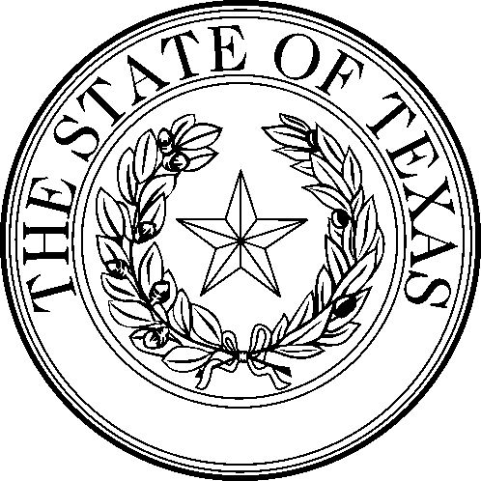

STATE BOARD OF BARBER EXAMINERS
5717 Balcones Dr., Ste 217
Austin, Texas 78731
(512) 936-6333 (888) 870-8755 FAX (512) 458-4901

AGENDA FOR TSBBE BOARD MEETING

Date & Time: Monday, August 1, 2005 at 2:30 p.m.

Meeting Location: 5717 Balcones Drive, Austin, Texas 78731

The Board may deliberate and take action regarding any item on the agenda. The Board may go into Executive Session for consultation with the Board’s attorney for matters authorized under Chapter 551.071 of the Texas Government Code, and/or for deliberation of personnel matters authorized under Chapter 551.074 of the Texas Government Code.

1. Pursuant to Chapter 551 of the Texas Government Code (Open Meetings), call to order and roll call by William H. Kuykendall, Chairman, Texas State Board of Barber Examiners or presiding officer.

2. Board will consider and possibly approve certificates of appreciation for barbers who have at least fifty (50) years of service to the people of Texas, or for other achievements, or who are recently deceased.

3. Consideration of and possibly take action on minutes from board meetings on June 6, 2005.

4. Public Comments

5. Consideration of and possibly take action on Proposals for Decisions (PFDs) from State Office of Administrative Hearings for SOAH hearings held on May 23, 2005 for the individuals listed below:

PFDs With Recommendations to Uphold:
1. Fredrick W. Cannon, File #222129, SOAH Docket #502-05-5221.W
2. Boniface Kangone, File # None, SOAH Docket #502-05-5227.W
3. Esther Dihn, File # None, SOAH Docket #502-05-5225.W
4. Earle Kobie Bonner, File #224833, SOAH Docket #502-05-5220.W
5. Marcus Richard, File #233339, SOAH Docket #502-05-5233.W
6. Reginald Arnold, File #225859, SOAH Docket #502-05-5218.W
7. Marcus Collins, File #237166, SOAH Docket #502-05-5223.W
8. Christopher Conley, File #232087, SOAH Docket #502-05-5224.W
9. Darryl Kemper, File #236580, SOAH Docket #502-05-5228.W
10. Dalwonderia Morgan, File #230406, SOAH Docket #502-05-5231.W
11. Derek Robinson, File #237062, SOAH Docket #502-05-5234.W
12. Melanie Nicole Simmons, File #228393, SOAH Docket #502-05-5235.W
13. Cheryln Swain, File #62593, SOAH Docket #502-05-5239.W
14. Farin Blevins, File #236537, SOAH Docket #502-05-5219.W
15. Ivory Armstead, File #228481, SOAH Docket #502-05-5217.W
16. Larry Eugene Skero, File #54970, SOAH Docket #502-05-5236.W
17. Larry E. Skerno, Jr., File # 65628, SOAH Docket #502-05-5237.W
18. Eric Krueger, File #238999, SOAH Docket #502-05-5229.W

PFDs With Recommendations to Dismiss:

None

6. Consideration of and possibly take action on Agreed Orders from Executive Director for Informal Hearings conducted with individuals who have received citations: (None at this time)

7. Consideration of and possibly take final action to repeal Rule 51.51 concerning the method of payment of fees.

8. Consideration of and possibly take final action to repeal Rule 51.55 concerning the required number of questions that shall be on examinations administered by the Board.

9. Consideration of and possibly take final action to repeal Rule 51.77 concerning requirements for a barber shop permit.

10. Consideration of and possibly take final action to amend the following Rules in preparation for transfer of functions to the Texas Department of Licensing and Regulation:

10.1 Amend Rule 51.12 to remove the requirement that the inspection of a proposed new barber school or
college be conducted specifically by two board members or by one board member and the executive
director.

10.2 Amend Rule 51.13(b) to remove the requirement that the inspection of a barber school or college
that has changed ownership be conducted specifically by two board members or one board member
and the board’s executive director.

10.3 Amend Rule 51.20 to remove requirement that enrollment form be notarized and remove
51.20(c)(4) requiring a health certificate for students.

10.4 Amend Rule 51. 21 to delete reference to physician statement.

10.5 Amend Rule 51.25 to delete reference to health certificate in 51.25(d).

10.6 Amend Rule 51.57 regarding examination applications to delete requirements in 51.57(b)(1) and
51.57(b)(2) that applications and school owner/manager statements be notarized, to delete reference
to health certificate in 51.57(b)(3), and to delete 51.57(b)(4) requiring payment by money order or
cashier’s check.

10.7 Amend Rule 51.60 to delete 51.60(c) regarding items to bring for wig specialist examination, which
is no longer offered.

10.8 Amend Rule 51.80 to delete reference to health certificate in 51.80(a)(4)

10.9 Amend Rule 51.85 to delete reference to specific fee amounts in 51.85(a) and 51.85(k); to delete
reference to physician’s certificate in 51.85(g), and to delete 51.85(k) in its entirety.

11. Consideration of and take action to repeal Rule 51.98 (Fees for Occupational Licensing Transactions Using the Internet) in compliance with HB 2593.

12. Consideration of and possibly take action on Executive Director’s Report. Executive Director Glenn Parker will give the Board an update on agency activities and operations and other topics of interest to the Board.

13. Consideration of and possible take action on agency newsletter for August, 2005. Glenn Parker will give the board a status report on the August newsletter.

14. Consideration of and possibly take action on agency financial and operations reports, including but not limited to year-to-date revenue and expenditure reports, student enrollment reports, and examination results report.

15. Final comments by board members, staff, and public concerning the Texas State Board of Barber Examiners as it prepares to merge into the Texas Department of Licensing and Regulation on September 1, 2005.

16. Adjourn

