BOARD MEMBERS

WILLIAM H. KUYKENDALL, J.D. CHAIRMAN
AUSTIN

RONALD L. BROWN
DRIPPING SPRINGS

MARY LOU DAUGHTREY
TYLER

JAMES H. DICKERSON, J.D.
LAKE JACKSON

SAN JUANA C. GARZA
WESLACO

TERISSA JOHNSON
SANGER

JANIS E. WIGGINS
KINGSLAND
GLENN D. PARKER
EXECUTIVE DIRECTOR
glenn.parker@tsbbe.state.tx.us

STATE BOARD OF BARBER EXAMINERS
http://www.tsbbe.state.tx.us
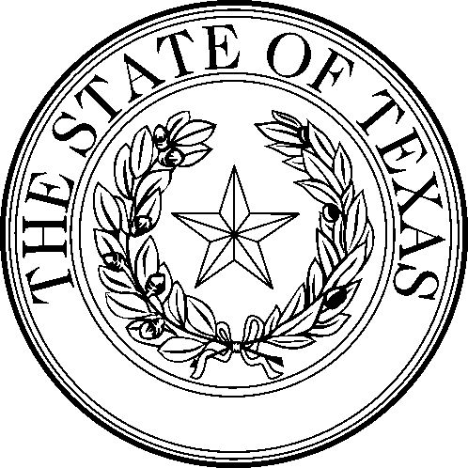

STATE BOARD OF BARBER EXAMINERS
5717 Balcones Dr., Ste 217
Austin, Texas 78731
(512) 936-6333 (888) 870-8755 FAX (512) 458-4901

TSBBE BOARD MEETING AGENDA
for
July 12, 2004 at 1:00 P.M. and July 13, 2004 at 9:00 A.M.
Meeting Location: 5717 Balcones Drive, Austin, Texas 78731

The Board may deliberate and take action regarding any item on the agenda.

The Board may go into Executive Session for consultation with the Board’s attorney under Chapter 551.071 of the Texas Government Code, and/or for deliberation of personnel matters under 551.074 of the Texas Government Code.

1. Pursuant to Chapter 551 of the Government Code (Open Meetings), call to order and roll call by William H. Kuykendall, J.D., Chairman, Texas State Board of Barber Examiners or presiding officer.

2. Review and approval of minutes for June 7, 2004 board meetings.

3. Public Comment

4. Consideration of and possibly take action on Agreed Orders (from Executive Director) for cases heard in Informal Hearings on June 14, 2004 and June 28, 2004.

5. Consideration of and possibly take action on Executive Director’s Report (general update on agency operations) including:

A. Agency implementation of audit recommendations.
B. Agency meetings with Cosmetology staff re: sharing resources.
C. Status of request for Attorney General’s Opinion regarding health certificate requirement and requirement to use Texas Online.
D. Update on Texas Online projects.
E. Other items as necessary.

6. Consideration of and possibly take action on agency reports including:

A. Financial Operations Report (YTD June 30, 2004)
B. Report on Fines and Receivables
C. Third Quarter Performance Report
D. Agency report on Schools and Enrollments (YTD June 30, 2004)
E. Agency report on Examinations (YTD June 30, 2004)
F. Other reports as necessary

7. Consideration of and possibly take action on report and recommendations from Board Committee on Shared Resources with Cosmetology.

8. Consideration of and possibly take action on continued regulation of manicurists by TSBBE. Board will consider pros and cons of transferring regulation of manicurists and specialty shops licensed by the Board to the Texas Cosmetology Commission.

9. Consideration of and possibly take action to finally adopt rule changes to Texas Administrative Code, Title 22, Part 2, Chapter 51, Subchapter D, Rule §51.98 to adopt new fees required by the Texas Online Authority.

10. Consideration of and possibly take action to finally adopt rule changes to Texas Administrative Code, Title 22, Part 2, Chapter 51, Subchapter B, Rule §51.12 to require new barber schools or colleges to pay required inspection or re-inspection fees before inspections will be scheduled by the Board.

11. Consideration of and possibly take action on possible changes to Rule 51.3 (Administrative Fines) to be proposed concerning eliminating required warnings for some categories of violations and replacing the 1st offence in those categories with fines.

12. Consideration of and possibly take action on rule changes to Rule 51.93 (Sanitation Rules) and Rule 51.3 (Administrative Fines) to be proposed to require regular, documented sanitation procedures for equipment and baths used for pedicures and/or manicures and to impose fines for violations as appropriate.

13. Consideration of and possibly take action on proposal to establish Board examination dates for fiscal year 2005.

14. Consideration of and possibly take action on proposal to establish Board meeting dates for remainder of fiscal year 2004 and fiscal year 2005.

15. Consideration of and possibly take action on proposal to change Rule 51.1 (Regular Meetings and Examinations) to eliminate the requirement that examinations and/or board meetings be held on days and months currently specified.

16. Consideration of and possibly take action on Strategic Plan for fiscal years 2005 -2009.

17. Consideration of and possibly take action on Legislative Appropriations Request for fiscal years 2006 and 2007.

18. Board to convene in Executive Session for deliberation of personnel matters under 551.074 of the Texas Government Code including, but not limited to, consideration of Board self-evaluation and evaluation of Executive Director.

19. Board to reconvene in open session and consider and possibly take action on items considered in Executive Session.

20. If time allows, Board may take up consideration of and possibly take action on Board legislative “wish list” for 79th Legislature. List was adopted in January, 2004 board meeting. Board will review its legislative wish list and consider the addition or deletion of items. Significant items currently included are: (1) request to delete TOC 1601.264 and 1601.402 requirements for health certificate to obtain or renew a barber license; (2) delete TOC 1601.301 requirement that barber must have practiced at least 12 months before obtaining a shop permit; (3) change TOC 1601.257 minimum age for manicurist license from 16 years of age to 17 years of age; (4) change TOC 1601.560 to allow 25:1 student/teacher ratio in barber schools rather than current 20:1; and other items. Complete list can be requested by contacting Glenn Parker, Executive Director, TSBBE at 512-936-6333 or glenn.parker@tsbbe.state.tx.us.

Board may consider and take action on requesting that the existing statutes governing the issuance of permits for barber shops and/or specialty shop be considered for revision by the Legislature.

21. Adjourn

